**DAILY ONLINE ACTIVITIES SUMMARY**

|  |  |  |  |  |  |  |  |
| --- | --- | --- | --- | --- | --- | --- | --- |
| **Date:** | **02/06/2020** | | | | **Name:** | **Churashma** | |
| **Sem & Sec** | **4th SEM 'A' Section** | | | | **USN:** | **4AL18CS019** | |
| **Online Test Summary** | | | | | | | |
| **Subject** | | **No test** | | | | | |
| **Max. Marks** | | **-** | | **Score** | | **-** | |
| **Certification Course Summary** | | | | | | | |
| **Course** | **Java programming** | | | | | | |
| **Certificate Provider** | | | **greatlearning academy** | **Duration** | | | **3.5 hours** |
| **Coding Challenges** | | | | | | | |
| **Problem statement 1:** Given an array of positive integers. Write a C Program to find inversion count of array.  **Problem statement 2:** Write a Java program to find Perfect Sum Problem.  **Problem statement 3:** Write a program in java, an array of integer data to be initialized. | | | | | | | |
| **Status: completed** | | | | | | | |
| **Uploaded the report in Github** | | | | **yes** | | | |
| **If yes Repository name** | | | | **https://github.com/Churashma/Lockdown-coding** | | | |
| **Uploaded the report in slack** | | | | **yes** | | | |

**ONLINE TEST DETAILS: No test**

**CERTIFICATION COURSE DETAILS:** Today I studied about collections in java.The Collection in Java is a framework that provides an architecture to store and manipulate the group of objects.Java Collection framework provides many interfaces (Set, List, Queue, Deque) and classes (ArrayList, Vector, LinkedList, PriorityQueue, HashSet, LinkedHashSet, TreeSet).

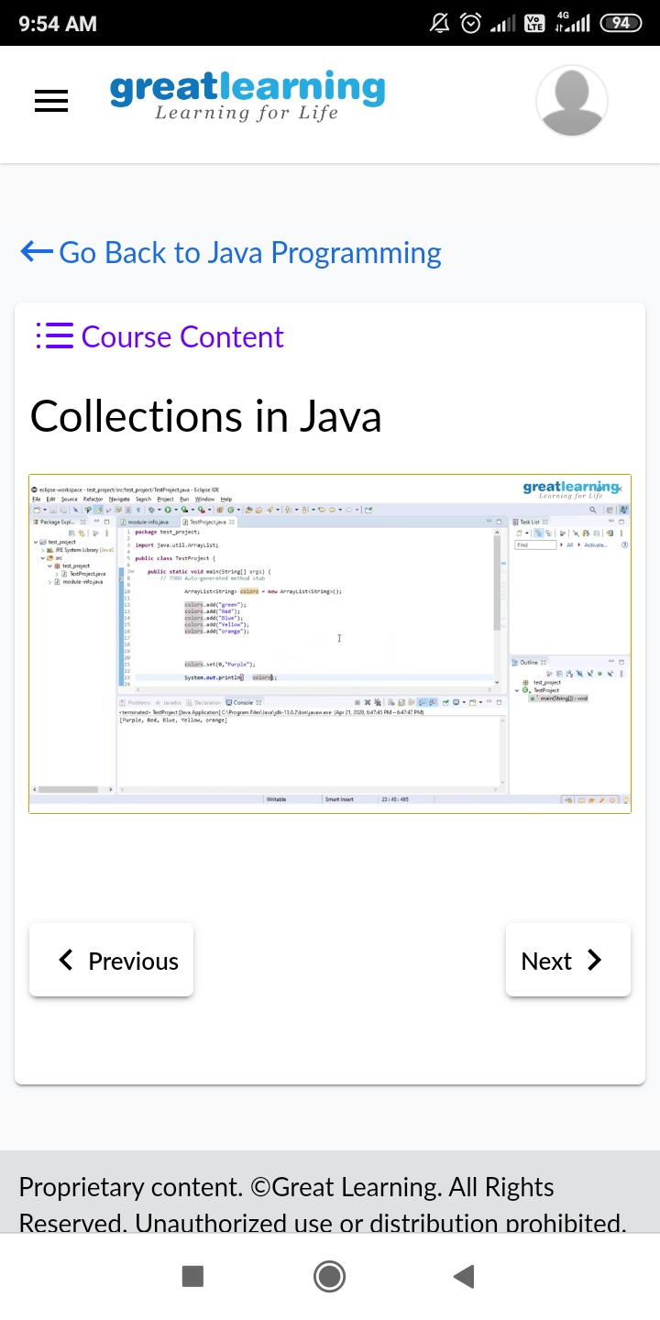

**CODING CHALLENGES DETAILS**:

**Problem statement 1:** Given an array of positive integers. Write a C Program to find inversion count of array.

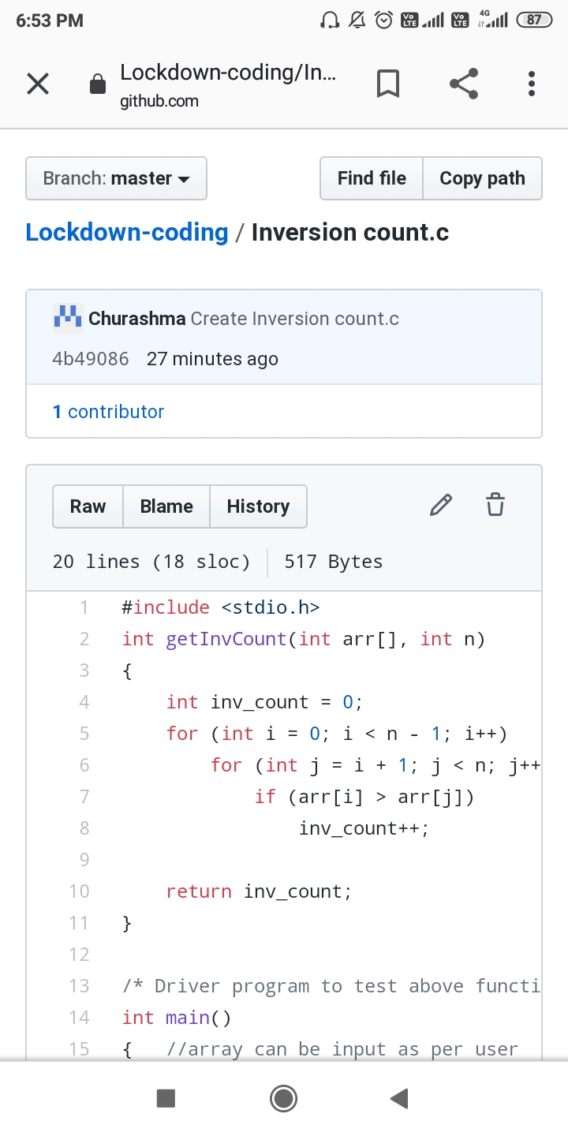

**Problem statement 2:** Write a Java program to find Perfect Sum Problem.

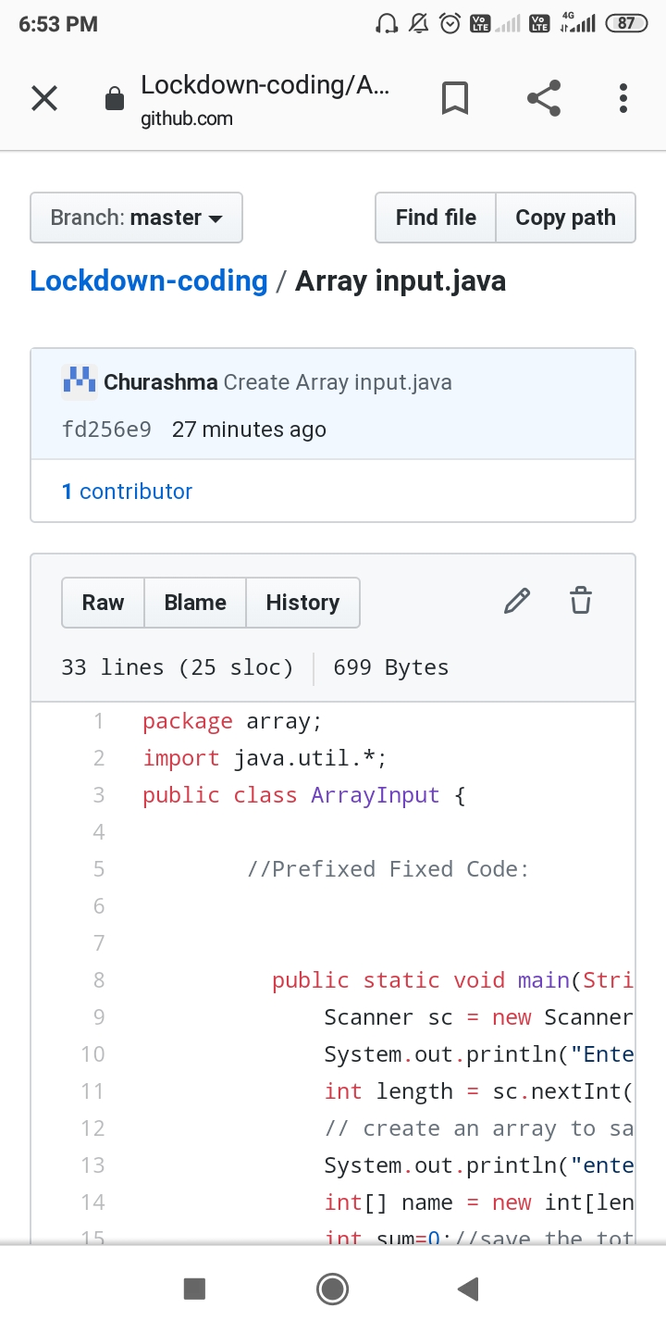

**Problem statement 3:** Write a program in java, an array of integer data to be initialized. During the initialization, if a user enters a value other than integer value, then it will throw InputMismatchException exception. On the occurrence of such an exception, your program should print “You entered bad data.” If there is no such exception it will print the total sum of the array.

